Postdoctoral Research Associate in Electrochemical Atomic Force Microscopy

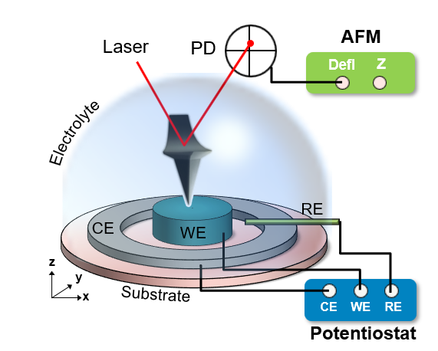
The Balke Research Group in the Department of Materials Science and Engineering at North Carolina State University is seeking a Postdoctoral Research Associate. The applicant will conduct research on the nanoscale functionality of energy storage materials with focus on supercapacitors and electrochemical batteries. This position will focus primarily on the use of atomic force microscopy techniques in liquid environment and under electrochemical control utilizing electro-chemo-mechanical coupling with the goal to identify the nature and local variations of electrochemical processes.

This position requires a Ph.D. in condensed matter physics, materials science, electrochemistry or a related field. The successful applicant should have a strong background in electrochemistry and basic electrochemical techniques with an understanding of electrochemical charge storage and in-situ cell development, or experience with atomic force microscopy in liquid environment. Familiarity with numerical data analysis and customization of control software is a plus (Labview, Matlab). Prior research work needs to be supported by a strong record of publications in peer-reviewed journals, preferably as a senior author, and presentations at scientific conferences. The applicant should be motivated, safety conscious and possess excellent oral and written communication skills. The applicant must have the ability to work in a team, interact effectively with colleagues and external collaborators.

About NC State: Located in Raleigh, North Carolina, NC State is the largest university in North Carolina, with more than 34,000 students and 8,000 faculty and staff. National rankings consistently rate Raleigh and its surrounding region among the five best places in the country to live and work, with a highly educated workforce, moderate weather, reasonable cost of living, and a welcoming environment. A collaborative, supportive environment for business and innovation and research collaborations with area universities and the Research Triangle Park are compelling reasons for relocation to the area.

NC State University is an equal opportunity and affirmative action employer. All qualified applicants will receive consideration for employment without regard to race, color, national origin, religion, sex, age, veteran status, or disability. In addition, NC State University welcomes all persons without regard to sexual orientation or genetic information.

To apply, please send a cover letter indicating interest and future career goals, CV, and contact information for 3 references to: nwising@ncsu.edu

